Diane is also available for individual consultations.
Please Mail or email registration to
Diane Hanley, 71 Labonte Farm Rd, Gilford, NH 03249
REGISTRATION

NAME OF CLASS: Location: _____

YOUR NAME AND ADDRESS:

TELEPHONE NUMBER:

EMAIL:

DOG’S NAME: BREED: AGE:

PLEASE NOTE: Treat ‘em Right, LLC requires that all dogs entering the facility be current on rabies and distemper, or be able to show veterinarian letter indicating titer levels.

AGREEMENT: In consideration of the acceptance of this registration and the opportunity to participate in any event held by Treat ‘em Right, LLC, I agree to hold Treat ‘em Right, LLC, Diane Hanley, the premises at which the event is located and their employees, assistants, guests and contractors harmless from any claim for the loss or injury which may be alleged to have been caused directly or indirectly to any person or thing by any act of dog or person while in or upon such premises or grounds or near the entrance thereto. I personally assume all responsibility and liability from such claim. I further agree to hold the aforementioned parties harmless from any claim of loss of this dog by disappearance, theft, death or injury to be caused or alleged to be caused by the negligence of the parties aforementioned or by the negligence of any other person or any other cause or causes. I hereby assume sole responsibility for and agree to indemnify and save the aforementioned parties harmless from any and all loss expenses, including legal fees.

PHOTO AND VIDEO RELEASE: Signature on this form allows Treat ‘em Right, LLC to use any videos or photos taken for its promotional and education purposes.
SIGNATURE: DATE:

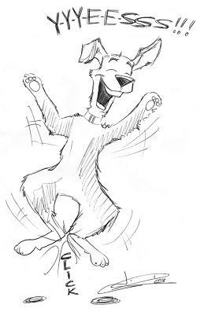
Please complete this questionnaire before returning your registration for this class.

I am Attending (Check one):
__________Puppy Skills (6-7pm, For Dogs 5 months and younger)

__________Drop-in Real World Socialization Skills (7-8 pm, dogs 6 months and older)

1. How does your dog react to other dogs? Happy, playful, fearful, lunging, barking..?

2. How does your dog react when meeting new people? Tail wagging, jumping, barking, fearful?

3. Does your dog run away or show his/her teeth, snarl, or growl when someone attempts to take food, toys or other items from his/her mouth?

4. What are some of your dog’s likes and loves? (Activities, toys, foods?)

5. What are some of your dog’s dislikes or fears?

6. How much exercise does your dog get?

7. What are your main goals for taking this training? What do you hope to get from class?

TREAT ‘EM RIGHT, LLC ProfessionaL Dog Training DIANE HANLEY (603) 387-3429

